Capstone weekly report5

After building the basic model, an error occurred, indicating that the DNN library was not found upon running the code. Consequently, I attempted several online solutions. Initially, I uninstalled the existing version of TensorFlow since it was not the latest one. Unfortunately, this did not resolve the error. Subsequently, I tried upgrading or downgrading TensorFlow, cuDNN, and CUDA versions to ensure their compatibility. Currently, I have TensorFlow version 2.13.0, CUDA toolkit version 11.6 installed, and multiple versions of cuDNN on my system, leaving me uncertain about which one to remove. The following image illustrates the compatible versions for TensorFlow, cuDNN, and CUDA.

I am planning to address the error this week. If no further errors occur, I will proceed with defining custom functions for data augmentation, conducting experiments on the filter coefficients, and comparing their effects on images with varying filter coefficients.

I have also read a paper titled "How Well Do Sparse ImageNet Models Transfer," and I plan to delve into new concepts introduced in the paper. These concepts include magnitude-based methods, second-order techniques, re-growth strategies, lottery-ticket approaches, and various regularization techniques. Additionally, I have reviewed how to calculate the output shape of a convolutional layer, which will be beneficial in restructuring my model.

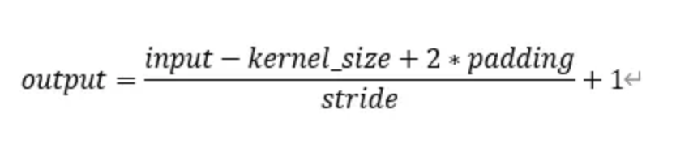

Related reading:

1. <https://dingyan89.medium.com/calculating-parameters-of-convolutional-and-fully-connected-layers-with-keras-186590df36c6> calculating parameters of convolutional and full connected layers with keras.
2. How Well Do Sparse ImageNet Models Transfer? <https://browse.arxiv.org/pdf/2111.13445v5.pdf>